* **Direct Manipulation:**

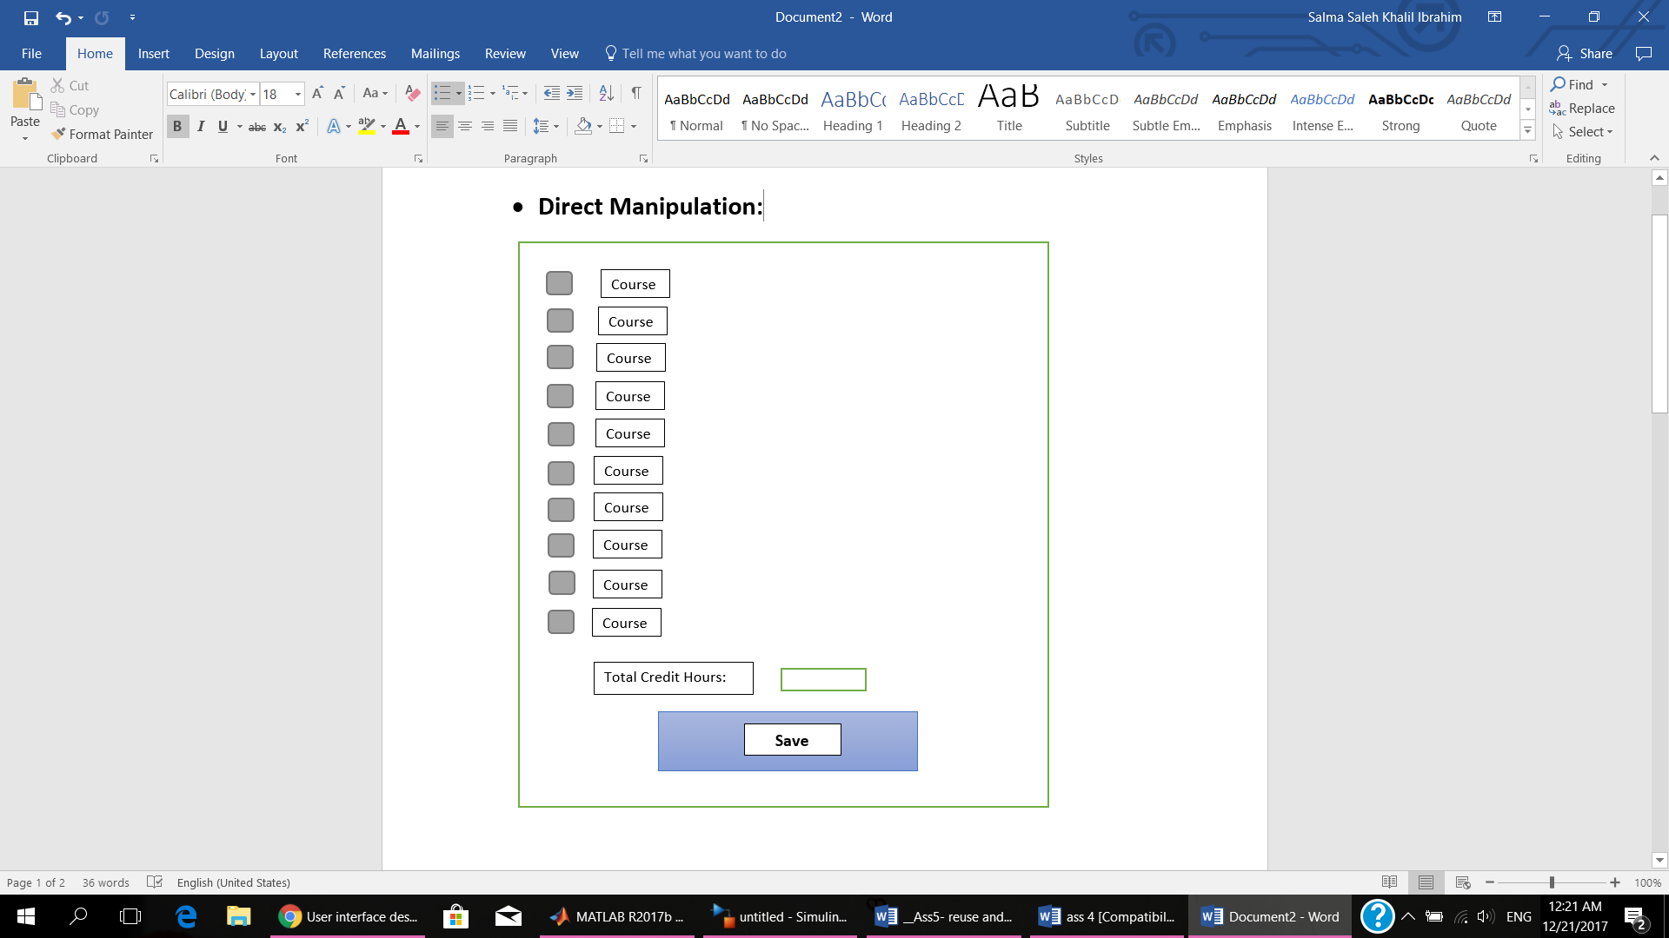**Registration**

* 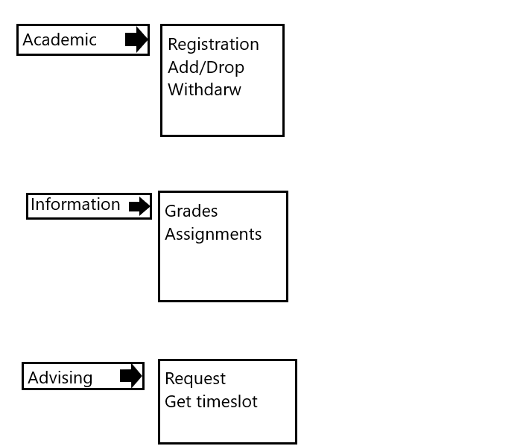**Menu Selection:**
* **Form Fill-in:**

**Registration**

Course 1:

Course 2:

Course 3:

Course 4:

Course 5:

Course 6:

Password:

ID:

**Login**